National Disability Voter Registration Week
July 16-20, 2018

Social Media Toolkit

The REV UP Campaign is coordinating National Disability Voter Registration Week (NDVRW) during the week of July 16-20, 2018 to make a concerted effort to get people with disabilities registered to vote, educated about this year’s election, and prepared to cast a ballot in November. With numerous events and activities happening around the country during this time, we also hope to garner attention from media and candidates running for office. Moving forward, we plan to hold NDVRW annually in the third week of July, just before the anniversary of the Americans with Disabilities Act (ADA).

The REV UP Campaign, launched by the American Association of People with Disabilities (AAPD) in 2016, is a nonpartisan initiative that coordinates with national, state, and local disability organizations to increase the political power of the disability community while also engaging candidates and the media on disability issues. The Campaign focuses on voter registration, education, access, and engagement. REV UP stands for Register! Educate! Vote! Use your Power!

Use this Social Media Toolkit to help us spread the word about NDVRW! For additional resources on organizing voter registration events and other ways to participate in NDVRW, please download the full NDVRW Toolkit.

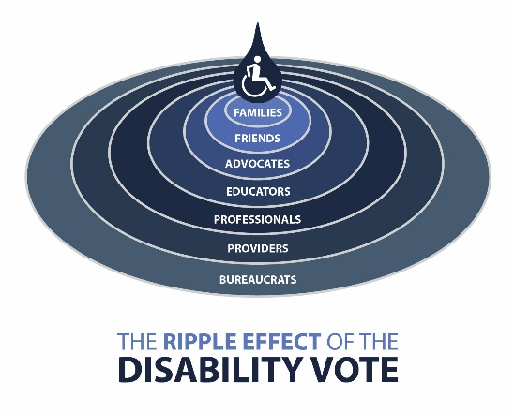

Logos, Images, Graphics, and Signs
The REV UP Campaign has several logos, graphics, images, and signs freely available for partners to use or modify for outreach and in promotional materials.

Access the REV UP Dropbox to view and download materials

Some examples of available logos and graphics include:

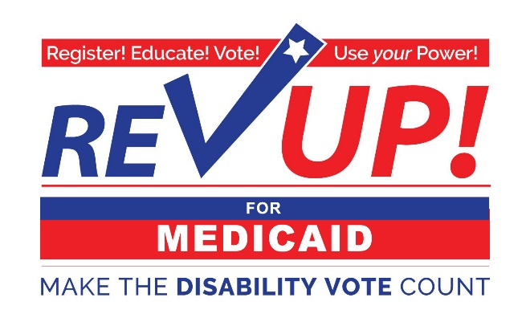 | 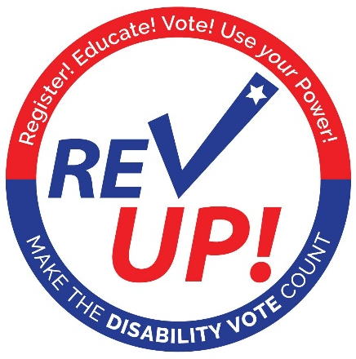
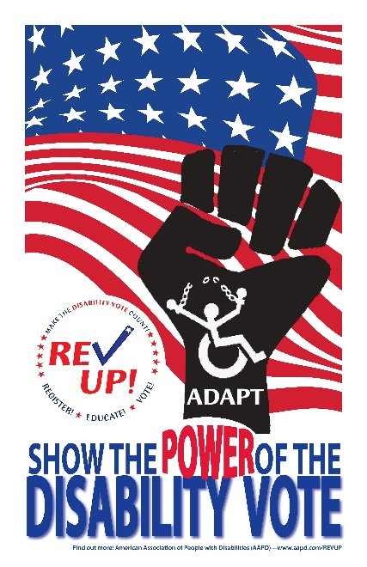 | 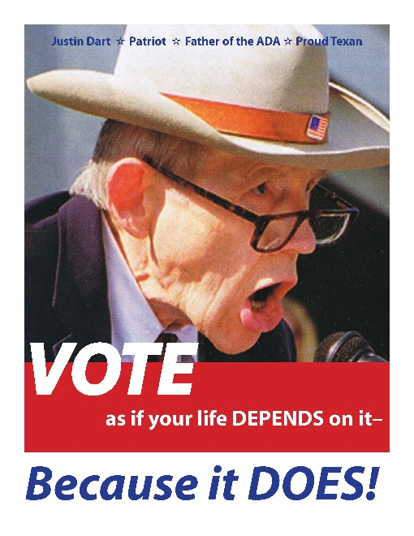

Sample Social Media Posts
Be sure to use #REVUP and #DisabilityVote18 when you post! You can also tag @AAPD on Twitter and @DisabilityPowered on Facebook.

National Disability Voter Registration Week 2018 is July 16-20 – Get registered!
www.aapd.com/NDVRW
#REVUP #DisabilityVote18

"VOTE as if your life depends on it—Because it DOES!" - Justin Dart
#REVUP #DisabilityVote18
www.aapd.com/REVUP
[post with the Justin Dart graphic]

Not registered to vote? The #REVUP Campaign has you covered! Check out their online voter registration tool powered by @RockTheVote: www.aapd.com/NDVRW
#DisabilityVote18

Are you ready to #REVUP‬ for National Disability Voter Registration Week 2018? Learn how you can get involved‬‬‬ this July. #DisabilityVote18‬‬‬‬‬‬‬‬‬‬‬‬‬‬‬‬‬‬
www.aapd.com/NDVRW

Ask your state and local elected officials to declare the week of July 16-20, 2018 as National Disability Voter Registration Week! Find a sample proclamation at www.aapd.com/NDVRW.
#REVUP #DisabilityVote18

[insert your organization’s name] is proud to be a part of the REV UP Campaign to increase the political power of the disability community! #REVUP #DisabilityVote18
Learn more at www.aapd.com/REVUP

[insert your organization’s name] is participating in National Disability Voter Registration Week this year! Visit [link to organizational website with event information] to learn more about our upcoming voter registration events! #REVUP #DisabilityVote18

In 2016, over 35 million people with disabilities were eligible to vote, but only 16 million did. Help us make sure our community is registered, educated, and engaged to exercise their civil right to vote! #REVUP #DisabilityVote18
www.aapd.com/REVUP

Want to #REVUP your state? Check out this list of state resources and events to see who is already organizing and where you can get involved. #DisabilityVote18
https://www.aapd.com/advocacy/voting/state-resources-and-events/

Voting policies vary by state - know the rules before going to the ballot box. Use this tool from @RockTheVote to learn about the voting policies in your state. #REVUP #DisabilityVote18
https://www.rockthevote.org/voting-information/

Verify your voter registration status and find your polling place with this tool from @HeadCountOrg: https://www.headcount.org/verify-voter-registration/
#REVUP #DisabilityVote18

VOTE. It's your right. A Guide to the Voting Rights of People with Mental Disabilities from @BazelonCenter, @autselfadvocacy, @NDRNadvocates, & @SRZLawFirm. #REVUP #DisabilityVote18
http://www.bazelon.org/wp-content/uploads/2017/01/voting-rights-guide-2016.pdf

.@SpreadTheVoteUS provides direct assistance to help voters obtain the proper identification to vote in their state. They are currently active in Florida, Georgia, Tennessee, Texas, and Virginia. #REVUP #DisabilityVote18
https://www.spreadthevote.org/

.@VoteRiders has wallet-sized Voter ID Info Cards (in English & Spanish) for all 50 states & DC. They also provide voter ID assistance to citizens in every state and host a Voter ID Hotline: 1-844-338-8743. #REVUP #DisabilityVote18
http://www.voteriders.org/voter-id-info-cards/

Young people and people with disabilities are underrepresented at the polls – that means that young people with disabilities have got to get out the vote! @rootedinrights #REVUP #DisabilityVote18
http://www.rootedinrights.org/videos/voting/youth-vote/

.@NpVOTE provides tools and resources to expand the role of America's nonprofits in promoting active civic participation and democracy. #REVUP #DisabilityVote18
http://www.nonprofitvote.org/

I vote to support #DisabilityRights! #REVUP #DisabilityVote18

I vote because it’s my right! #REVUP #DisabilityVote18

The #REVUP Campaign aims to increase the political power of people with disabilities through voter registration, education, and engagement. Learn more at www.aapd.com/REVUP. #DisabilityVote18

Social Media Photo Campaign
This year, we are encouraging advocates and voters to post a selfie or photo of themselves holding a sign to express their commitment to voting in the upcoming election.

Instructions
- Print out a sign (templates are linked below)
- Write something on your sign (if applicable)
- Take a selfie of yourself and the sign or ask a friend to take a photo of you holding it
- Post the photo to Facebook or Twitter
- Be sure to tag your post with #REVUP and #DisabilityVote18
- Please also tag AAPD – we are on Facebook at @DisabilityPowered and Twitter at @AAPD

Premade signs include:
- “I vote to support disability rights!”
- “I am a disabled voter!”
- “I vote because it’s my right!”
- “I vote because…” (write your own message)
- Blank template
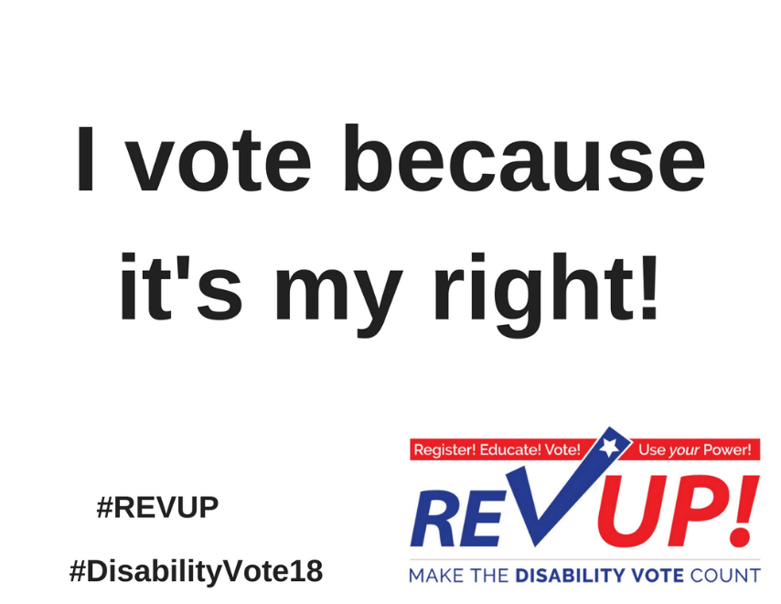

Press Release Template
The press release template linked below is open for REV UP partners to use and modify as they see fit to promote their involvement with National Disability Voter Registration Week this year.
- Press Release Template – REV UP National Disability Voter Registration Week 2018

Some considerations for your press release:
- Please use “National Disability Voter Registration Week” and mention the REV UP Campaign in your release. This helps us build brand awareness around NDVRW and identifies the REV UP Campaign as a national effort to increase the political power and participation of people with disabilities.
- Clearly indicate the details about your voter registration events (date, time, location, and organizer contact information).
- Send the release to state and local media in advance of your event.

Request a Proclamation
A great way to raise awareness about NDVRW is to advocate for your state, city, town, etc. to recognize it. You can reach out to your Governor, Mayor, City Council, County Commissioner, State Representative, etc. to request that they issue a proclamation declaring the week in question National Disability Voter Registration Week (a draft Proclamation is available here). This is a great way to develop or leverage a relationship with your local and state government. Please send any Proclamations you get to programs@aapd.com so we can show the influence and support of REV UP across the country!

Questions?
Do you have questions about National Disability Voter Registration Week or need additional resources? Let us know! Email programs@aapd.com.

Thank You!

