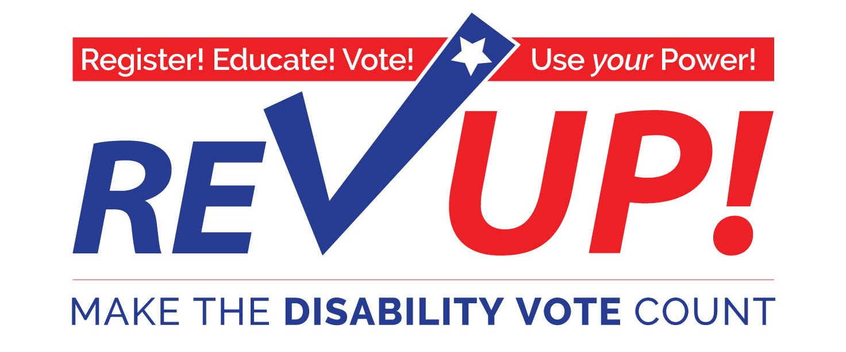

Sample Social Media Posts

Below are a selection of Facebook and Twitter posts promoting the REV UP Campaign and available resources for organizing in your community. Please feel free to edit, adapt, and customize these posts as you see fit. REV UP logos and images are available on the AAPD website (http://www.aapd.com/our-focus/voting/rev-up-images-and-toolkits/) and are also free for your use and customization.

As you are organizing around voting in your own community please keep us (AAPD) informed of your activities so we can capture the breadth of disability vote organizing and also help promote your event and resources. Please contact Zach Baldwin at zbaldwin@aapd.com or 202-521-4310.

Facebook:

Time to REV UP and make the DISABILITY VOTE count!
www.aapd.com/REVUP
[upload REV UP logo]

Have you registered to vote? The REV UP Campaign offers an online voter registration tool powered by Rock The Vote to get you registered and prepared to cast a ballot this November. Check it out!
http://www.aapd.com/our-focus/voting/national-disability-voter-registration-week/

"VOTE as if your life depends on it—Because it DOES!" - Justin Dart #REVUP #VoteDisability www.aapd.com/REVUP
[post with the Justin Dart graphic]

Declare July 17-21 as National Disability Voter Registration Week in your state, county, or city.
http://www.aapd.com/our-focus/voting/national-disability-voter-registration-week/
[upload REV UP logo]

Are you ready to REV UP‬ for National Disability Voter Registration Week? Learn how you can get involved:‬‬‬
http://www.aapd.com/our-focus/voting/national-disability-voter-registration-week/

Want to REV UP your state? Check out this list of state resources and events to see who’s already organizing in your state and where you can have an impact.
http://www.aapd.com/our-focus/voting/state-resources-and-events/

Check out the REV UP Voter Resource Center for information on registering to vote, policies impacting voters with disabilities, candidates and issues in the current election, and how you can be a catalyst to make the DISABILITY VOTE count!
http://www.aapd.com/our-focus/voting/voter-resource-center/

Learn how to make your organization a polling place for people with disabilities.
http://www.aapd.com/our-focus/voting/national-disability-voter-registration-week/

Twitter:

#REVUP and make the #DISABILITY #VOTE count!
www.aapd.com/REVUP
[upload REV UP logo]

Not registered to vote? The #REVUP Campaign's got you covered! Check out their online voter registration tool:
http://www.aapd.com/our-focus/voting/national-disability-voter-registration-week/

"VOTE as if your life depends on it—Because it DOES!" - Justin Dart #REVUP #VoteDisability www.aapd.com/REVUP
[post with the Justin Dart graphic]

Declare July 17-21 as National Disability Voter Registration Week in your community.
http://www.aapd.com/our-focus/voting/national-disability-voter-registration-week/
#REVUP #VoteDisability

Are you ready to #REVUP for National Disability Voter Registration Week? | July 17-21 #VoteDisability #CripTheVote
http://www.aapd.com/our-focus/voting/national-disability-voter-registration-week/

National Disability Voter Registration Week 2017 is July 17-21 - get registered
http://www.aapd.com/our-focus/voting/national-disability-voter-registration-week/
#REVUP #VoteDisability #CripTheVote

Want to #REVUP your state? Check out this list of state resources and events:
http://www.aapd.com/our-focus/voting/state-resources-and-events/
#VoteDisability #CripTheVote

The #REVUP Voter Resource Center - info on registration, policies, candidates, & the power of the DISABILITY VOTE!
http://www.aapd.com/our-focus/voting/voter-resource-center/

Make your organization a polling place for people with disabilities.
http://www.aapd.com/our-focus/voting/national-disability-voter-registration-week/
#REVUP #VoteDisability #CripTheVote

Image Descriptions
When posting to Facebook and Twitter please be sure to include image descriptions for any photos, logos, or graphics you post to ensure your outreach is accessible to everyone. Below are image descriptions you can use for the REV UP logos and graphics AAPD provides

*Note: For the best quality image please download the REV UP logos and images from http://www.aapd.com/our-focus/voting/rev-up-images-and-toolkits/

Image | Image Description
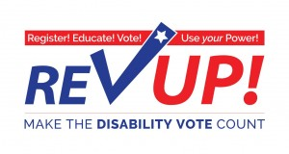 | REV UP - Register! Educate! Vote! Use your Power! Make the DISABILITY VOTE count!
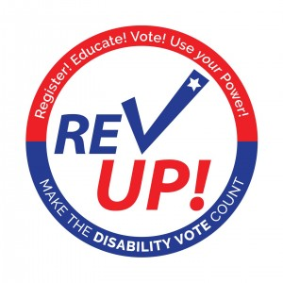 | REV UP - Register! Educate! Vote! Use your Power! Make the DISABILITY VOTE count!
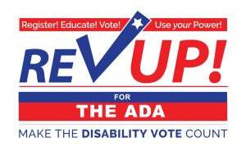 | REV UP! for the ADA - Register! Educate! Vote! Use your Power! Make the DISABILITY VOTE count!
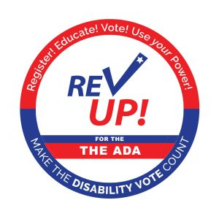 | REV UP! for the ADA - Register! Educate! Vote! Use your Power! Make the DISABILITY VOTE count!
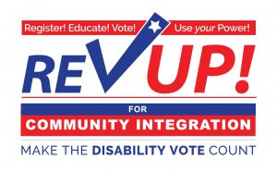 | REV UP! for community integration - Register! Educate! Vote! Use your Power! Make the DISABILITY VOTE count!
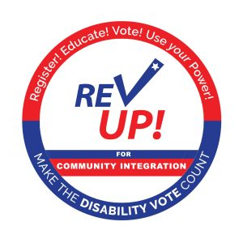 | REV UP! for community integration - Register! Educate! Vote! Use your Power! Make the DISABILITY VOTE count!
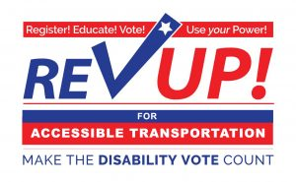 | REV UP! for accessible transportation - Register! Educate! Vote! Use your Power! Make the DISABILITY VOTE count!
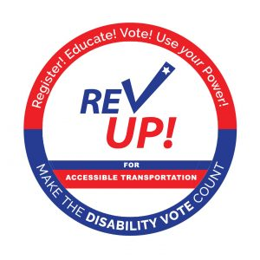 | REV UP! for accessible transportation - Register! Educate! Vote! Use your Power! Make the DISABILITY VOTE count!
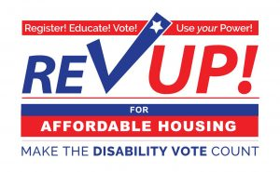 | REV UP! for affordable housing - Register! Educate! Vote! Use your Power! Make the DISABILITY VOTE count!
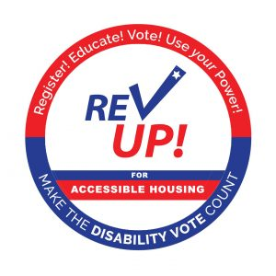 | REV UP! for accessible housing - Register! Educate! Vote! Use your Power! Make the DISABILITY VOTE count!
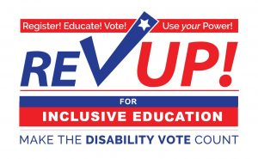 | REV UP! for inclusive education - Register! Educate! Vote! Use your Power! Make the DISABILITY VOTE count!
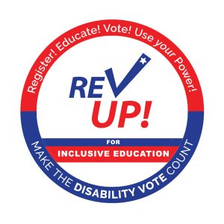 | REV UP! for inclusive education - Register! Educate! Vote! Use your Power! Make the DISABILITY VOTE count!
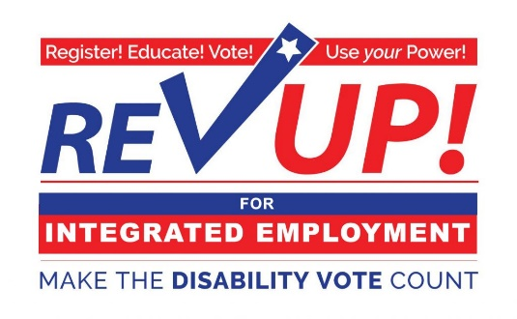 | REV UP! for integrated employment - Register! Educate! Vote! Use your Power! Make the DISABILITY VOTE count!
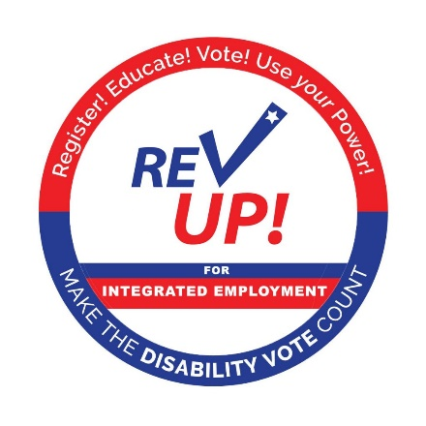 | REV UP! for integrated employment - Register! Educate! Vote! Use your Power! Make the DISABILITY VOTE count!
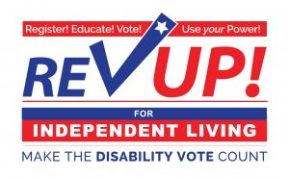 | REV UP! for independent living - Register! Educate! Vote! Use your Power! Make the DISABILITY VOTE count!
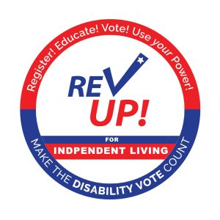 | REV UP! for independent living - Register! Educate! Vote! Use your Power! Make the DISABILITY VOTE count!
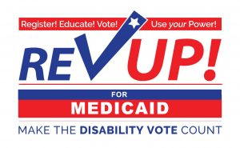 | REV UP! for Medicaid - Register! Educate! Vote! Use your Power! Make the DISABILITY VOTE count!
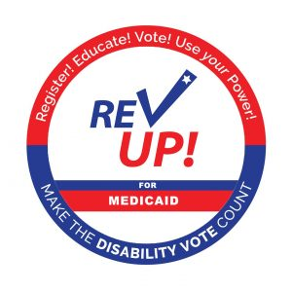 | REV UP! for Medicaid - Register! Educate! Vote! Use your Power! Make the DISABILITY VOTE count!
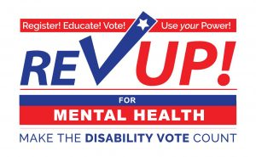 | REV UP! for mental health - Register! Educate! Vote! Use your Power! Make the DISABILITY VOTE count!
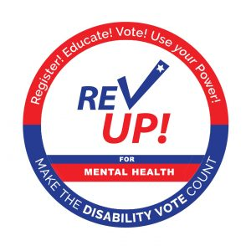 | REV UP! for mental health - Register! Educate! Vote! Use your Power! Make the DISABILITY VOTE count!
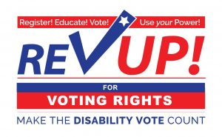 | REV UP! for voting rights - Register! Educate! Vote! Use your Power! Make the DISABILITY VOTE count!
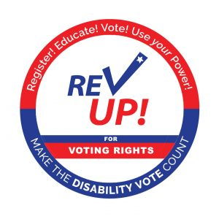 | REV UP! for voting rights - Register! Educate! Vote! Use your Power! Make the DISABILITY VOTE count!
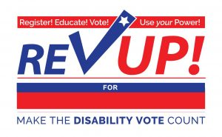 | REV UP! for (blank) - Register! Educate! Vote! Use your Power! Make the DISABILITY VOTE count!
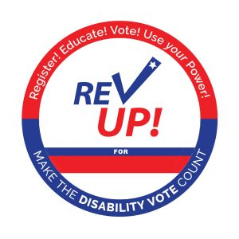 | REV UP! for (blank) - Register! Educate! Vote! Use your Power! Make the DISABILITY VOTE count!
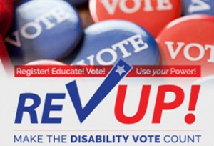 | REV UP logo (REV UP - Register! Educate! Vote! Use your Power! Make the DISABILITY VOTE count!) over a background of red and blue buttons with "vote" printed on them
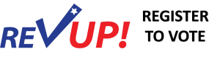 | REV UP logo with the "v" as a check mark with a star at the top; text "REGISTER TO VOTE" to the right of the logo
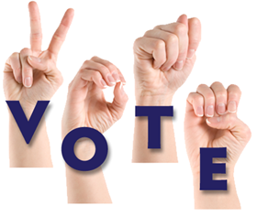 | Image of "vote" in ASL with hands signing
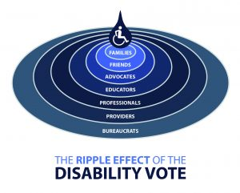 | Raindrop ripple with words (Families, Friends, Advocates, Educators, Professionals, Providers, Bureaucrats) going from center to outside ring
 | Animation: Text The Ripple Effect of the Disability Vote at the top of image. Underneath Icon of a Drop of water with an Icon of an active person in the wheelchair Slowly fades in ringed layers of Families Friends Advocates Educators Professionals Providers Bureaucrats Simulating a drop creating a ripple effect in a larger body of water.
 | Animation: REV UP in bold American flag Font then quickly shifts to Bold capital letters Register Educate Vote slight break Then the words one at a time with a pause in between Use Your Power Ending on the REV UP Logo
 | Animation: "Register" in bold red letters above a map of the US that gradually fills in each state, followed by "Educate, Vote, Use your Power" and the REV UP logo
 | Animation: "Vote as if your life depends on it, because it does!" "-Justin Dart" animated in red and blue, followed by text "use your power" and round REV UP logo and
 | Animation: "Self Advocacy begins by understanding that rights are never granted from above, they are grasped from below by those with the courage and determination to seize that to which they are entitled." - The Honorable Tony Coelho, followed by "Use your Power" and the round REV UP logo
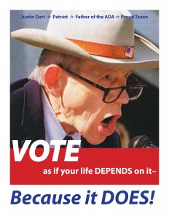 | Photo of Justin Dart with text: "VOTE as if your life depends on it - Because it DOES!
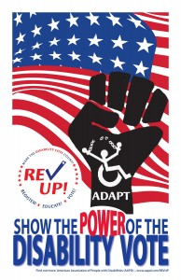 | Poster with an US flag in the background, the REV UP logo, the ADAPT fist logo, and text "Show the power of the disability vote"
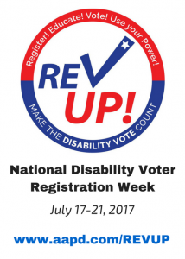 | Flyer for National Disability Voter Registration Week 2017 - REV UP logo (REV UP - Register! Educate! Vote! Use your Power! Make the DISABILITY VOTE count!) above text "National Disability Voter Registration Week 2017 July 17-21, 2017 www.aapd.com/REVUP"

